Virtual Machines

# Task 1: Installation of Android on VirtualBox

## 1.1: Why so many options?

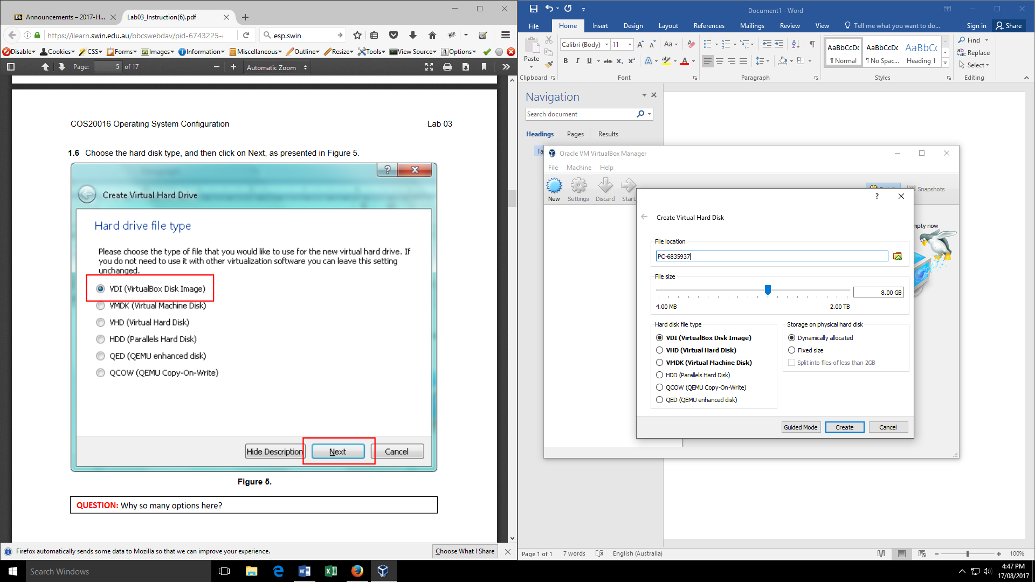

In the default view, there are only the 3 bolded options available. The version in the pdf for the lab might be an older version, but by clicking on the expert mode button, we are able to see all of the options. The reason there are so many options is so that you can select which disk you are going to use. Each disk preforms a different task:

* VDI (virtualBox Disk Image) – Is an image of a virtual hard disk
* VHD (Virtual Hard Disk) – This disk is like a physical hard disk, but is a virtual one instead.
* VMDK (Virtual Machine Disk) – Is the file format that contains virtual hard disk drives for virtual machines.
* HDD (Parallels Hard Disk) – This disk is a physical hard disk.
* QCOW (QEMU Copy-On-Write) – This disk is used to host a virtual machine monitor.
* QED (QEMU enhanced disk) – This disk supports backing up files.

## 1.2: Setup completed

Here is the virtual machine after it has been setup.

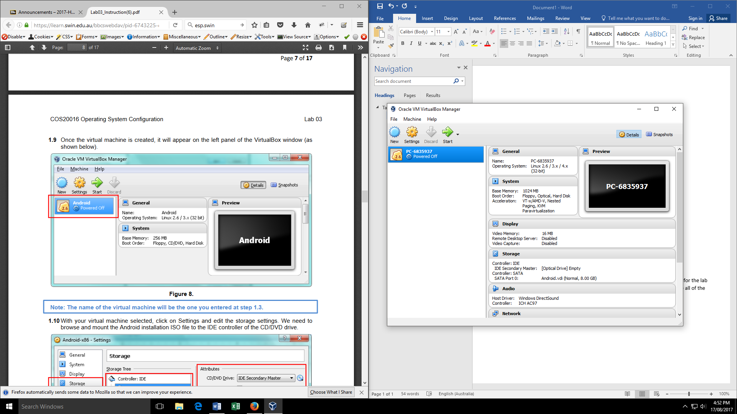

## 1.3: System running

When we first booted up the system after setting up the virtual machine, this was the window that opened for us to install the IOS that we downloaded.

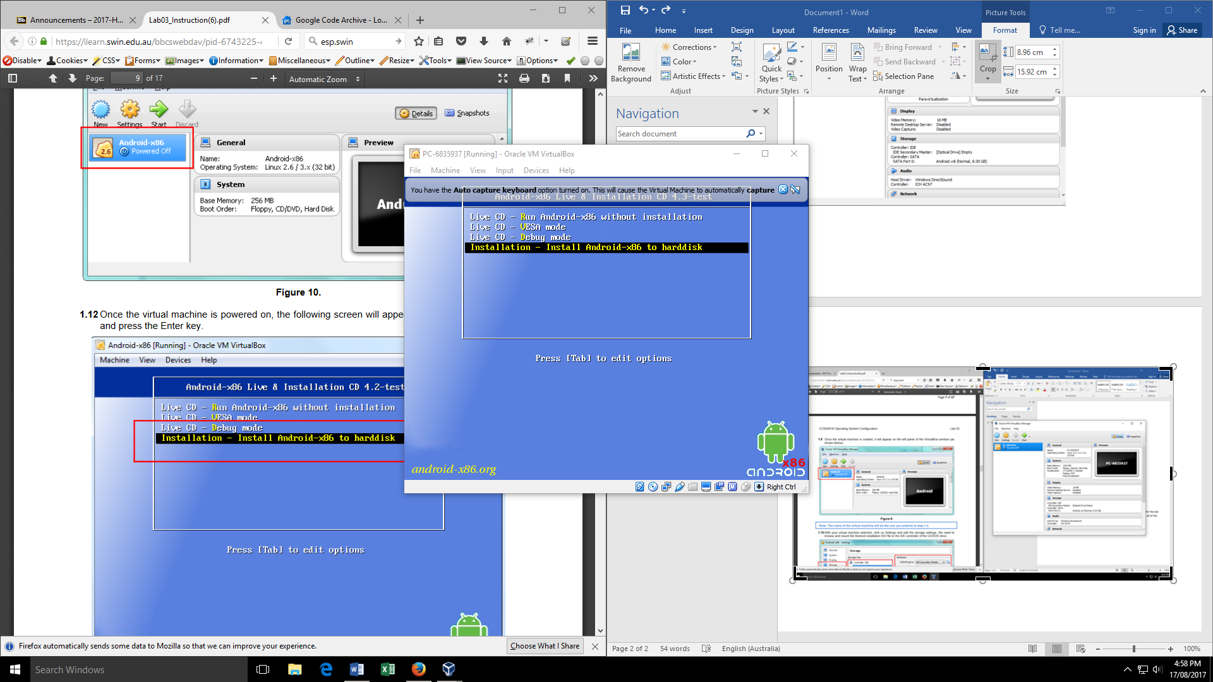

This image shows the system up and running after all setup and installations are completed

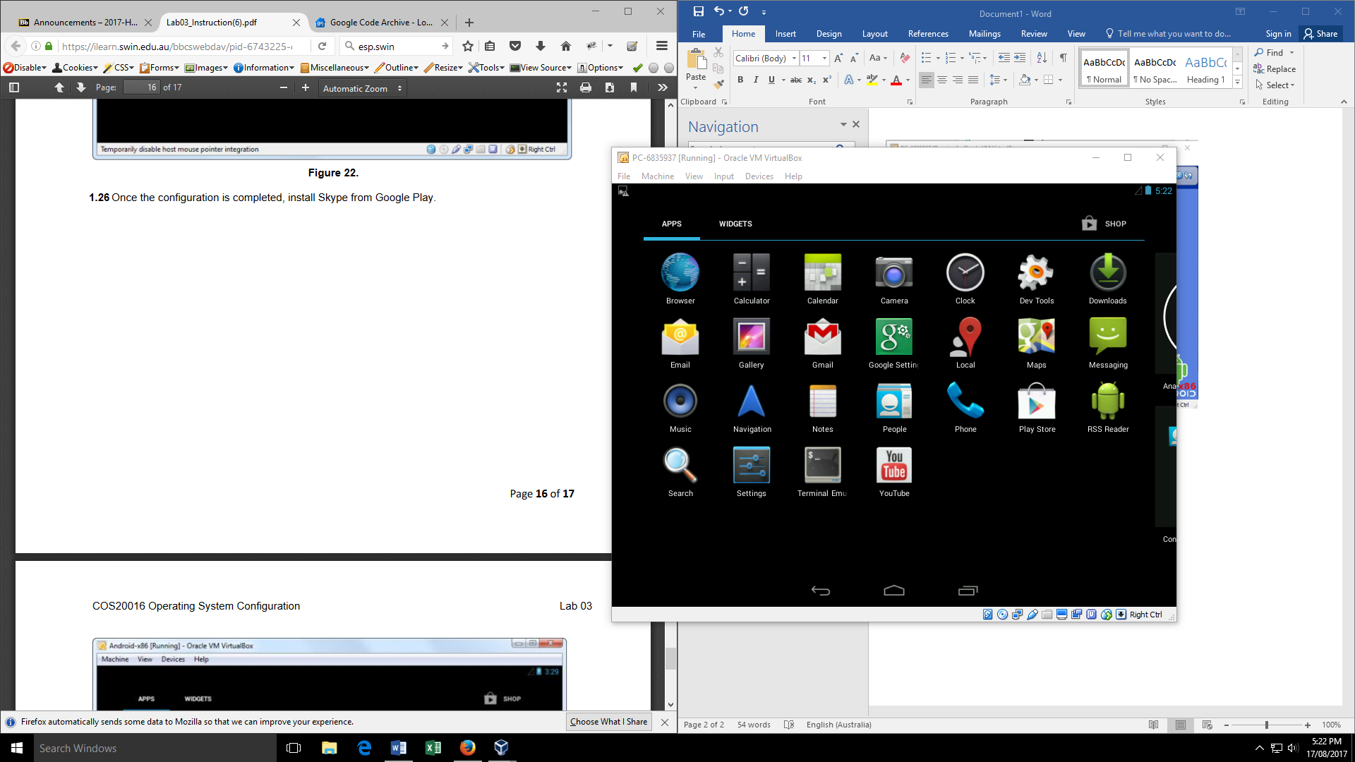

## 1.4: Installing Skype

Here I am showing skype located in the google apps store.

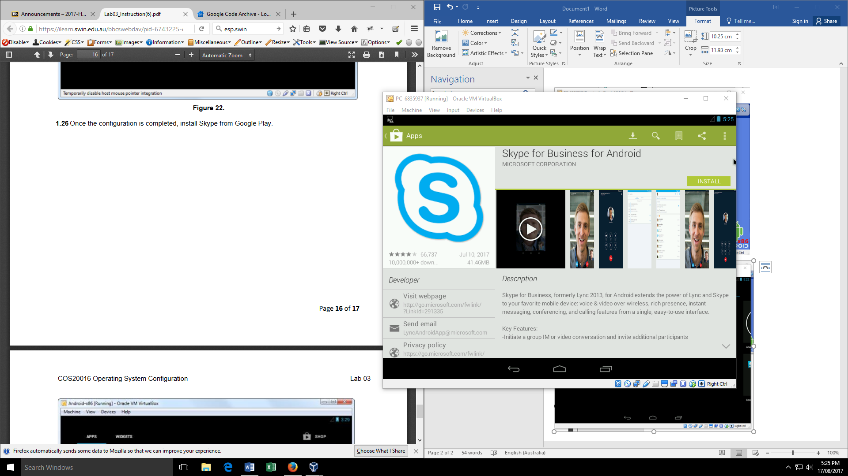

Here is skype installing on Android virtual machine.

